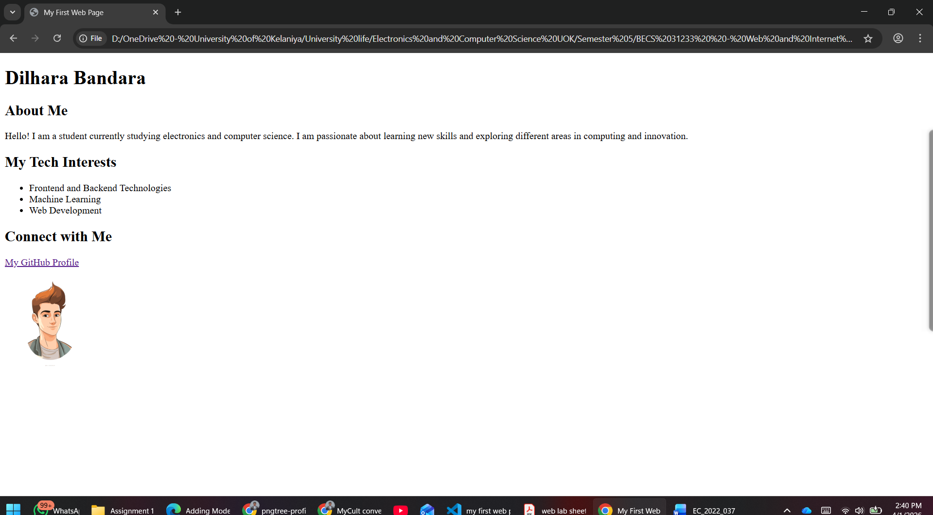
<!DOCTYPE html>
<html lang="en">
<head>
<meta charset="UTF-8">
<meta name="viewport" content="width=device-width, initial-scale=1.0">
<title>My First Web Page</title>
</head>
<body>
<h1>Dilhara Bandara</h1>

<h2>About Me</h2>
<p>
Hello! I am a student currently studying electronics and computer science.
I am passionate about learning new skills and exploring different areas
in computing and innovation.
</p>

<h2>My Tech Interests</h2>
<ul>
<li>Frontend and Backend Technologies</li>
<li>Machine Learning</li>
<li>Web Development</li>
</ul>

<h2>Connect with Me</h2>
<p>
<a href="https://github.com/dilhara003" target="_blank">My GitHub Profile</a>
</p>

<img
src="https://i.ibb.co/xSgKWVZj/pngtree-profile-pic-vector-png-image-6882563.png"
alt="Profile picture placeholder"
width="150"
>
</body>
</html>

